GOOGLE HANGOUTS MEET FOR REMOTE WORKING:

Google's Hangouts Meet is a G Suite conferencing tool that allows teams to gather in one place and discuss affairs over video, text, and audio chat. Many people are turning to Meet to working from home which has become the norm due to Coronavirus (COVID-19). It's relatively simple to navigate and use. Its free for all staff with university email. The meeting can accommodate upto 100 members and it can support upto 24hours meeting duration
Please see the video below that will guide through initiating a meeting/class.
- https://www.youtube.com/watch?v=gm4s-D2-lyY
- https://www.youtube.com/watch?v=4KPVT0TjCrc
Please contact ICTS for further details and support.

Menu
- How to create or join a Hangouts Meet
- How to invite people to your Hangouts Meet
- How to configure your camera, speakers, and mic in Hangouts Meet
- How to share your screen in Hangouts Meet
- How to send a text message in Hangouts Meet
- How to remove someone from Hangouts Meet
- How to lock view on one person in Hangouts Meet
- How to change the layout of Hangouts Meet

How to create or join a Hangouts Meet
if you are part of a G Suite team, you can create a Meet. Here's how it's done on PC.
- Visit the Google Hangouts Meet landing page in your favorite browser. If you're not signed into Google, do so now.
- Click Join or start a meeting.
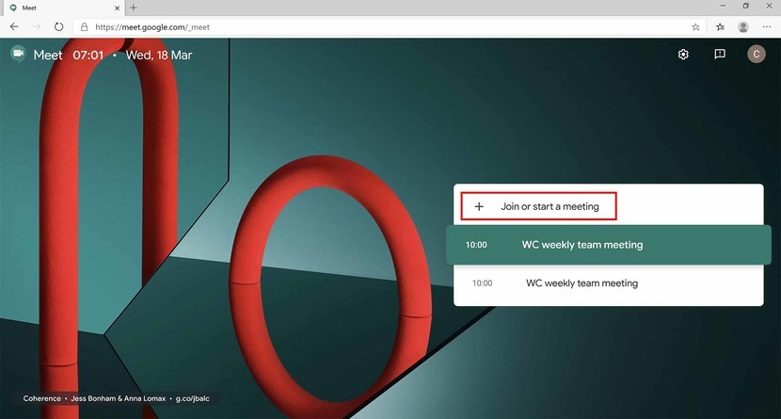Source: Windows Central
- Type a nickname or leave the field blank.
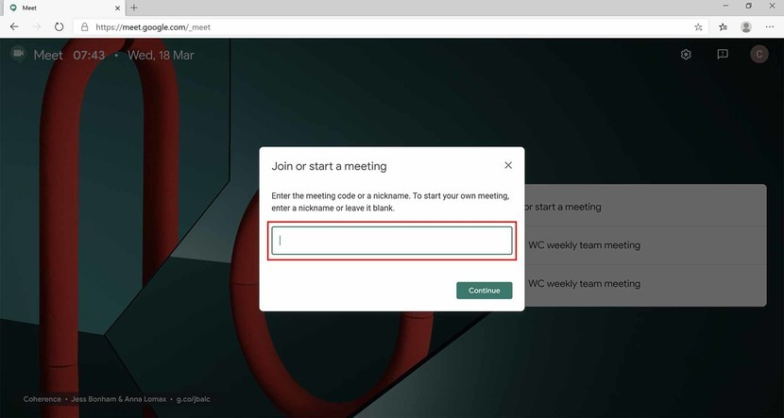Source: Windows Central
- Click Continue.
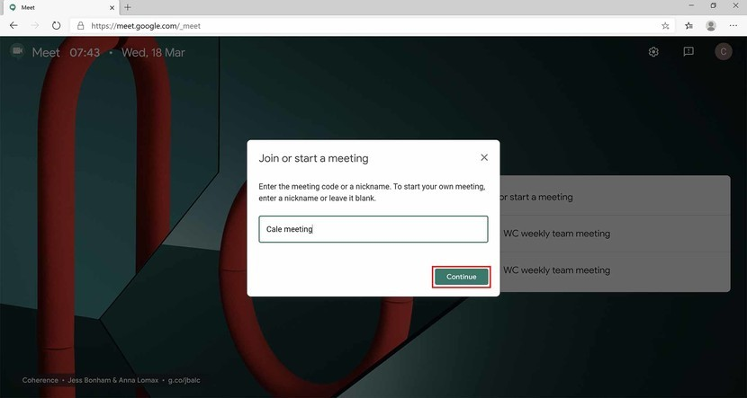Source: Windows Central
- Click Join now.
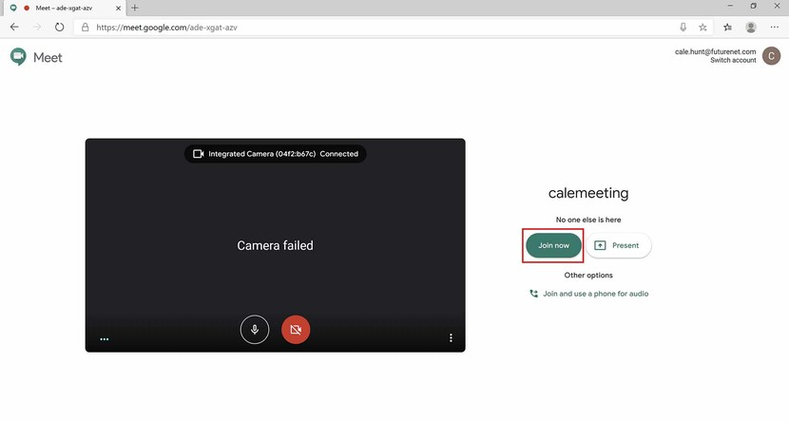Source: Windows Central
You've now created a Meet that can be joined by other people, even if they're not part of a G Suite plan. Upon joining the Meet you just created, you'll be presented with a small popup window containing important details for having colleagues join.

How to invite people to your Hangouts Meet
Clicking the Copy joining info button from the introductory popup window will save the details to your PC's clipboard, which you can paste into an email or other messaging system. From there, all the invitee has to do is use the link to join the Meet. If you've gone past the popup, fret not. You can simply copy and paste the Meet's URL from the address bar of your browser.
You can also add more people directly from within the Meet. Here's how it's done.
- Click the People button near the top-right corner of the screen.
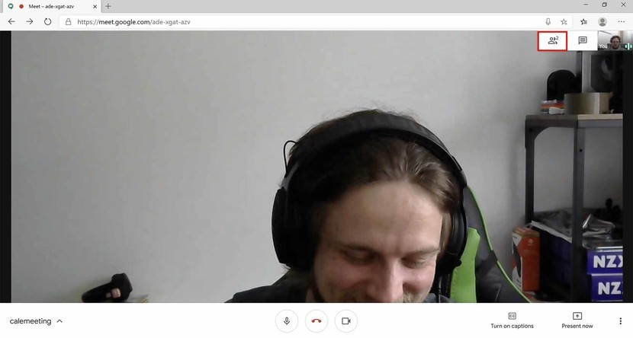Source: Windows Central
- Click Add people.
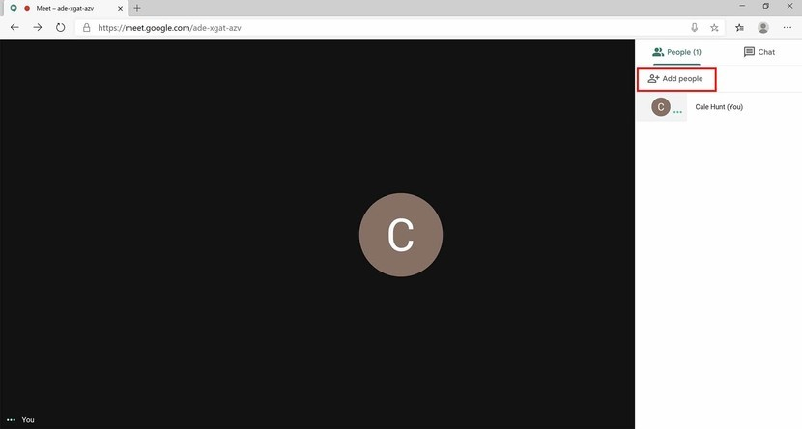Source: Windows Central
- Type a name or email address depending on who you're inviting. If they're a part of your G Suite network, you should be able to easily find the person by name.
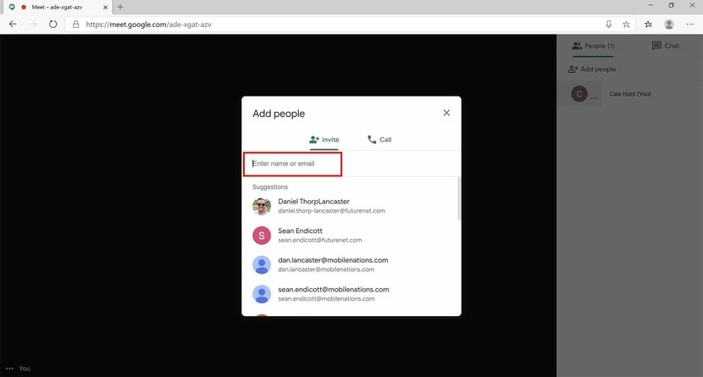Source: Windows Central
- Click Send invitation.
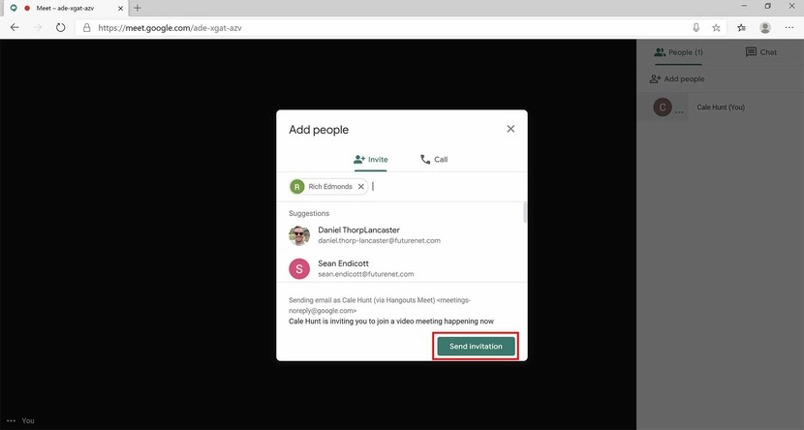Source: Windows Central
Within this People tab, you can also see a full list of the people within the Meet session.

How to configure your camera, speakers, and mic in Hangouts Meet
Meet recognizes hardware that's connected or built into your PC, and most of the time, it will automatically use the default configuration. However, if your microphone, camera, or speakers aren't working properly, you can check the settings menu to change input and output.
- Click the Options button in the bottom-right corner. It looks like three dots stacked on top of each other.
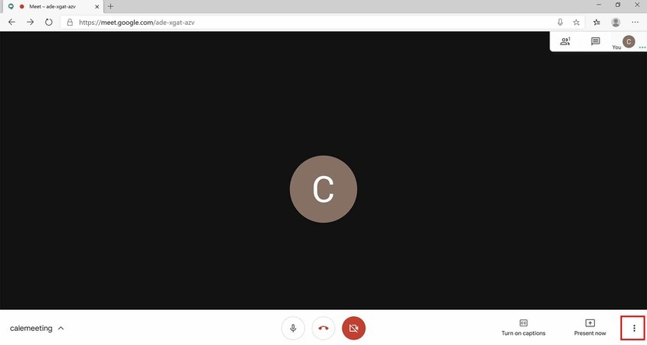Source: Windows Central
- Click Settings.
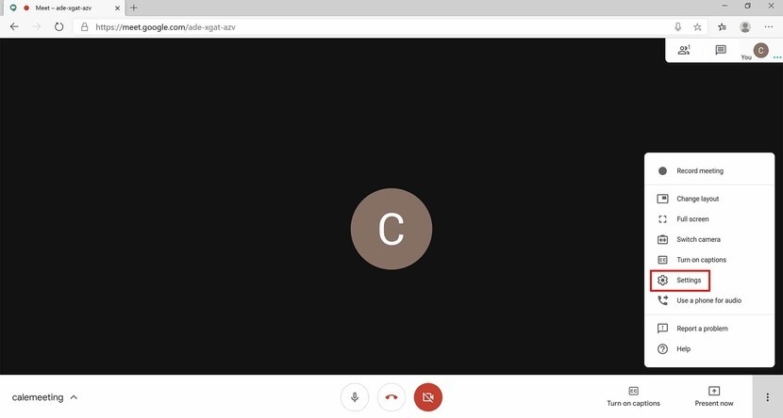Source: Windows Central
- Click the dropdown menu below Microphone to choose an audio input.
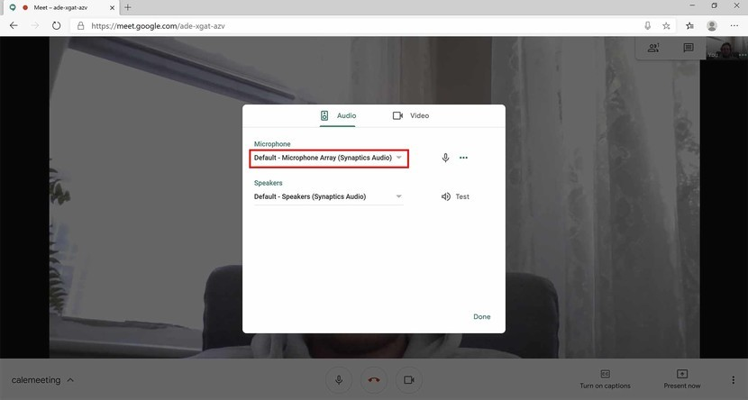Source: Windows Central
- Click the dropdown menu below Speakers to choose an audio output.
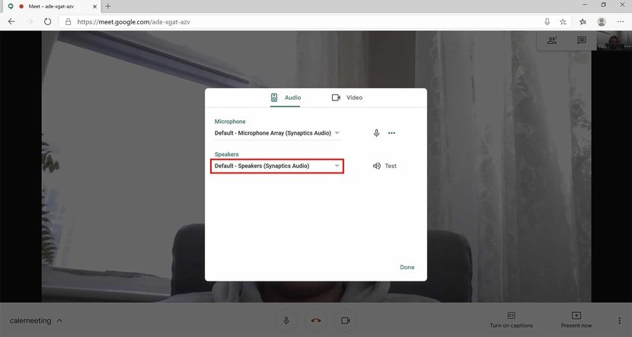Source: Windows Central
- Click the Video tab.
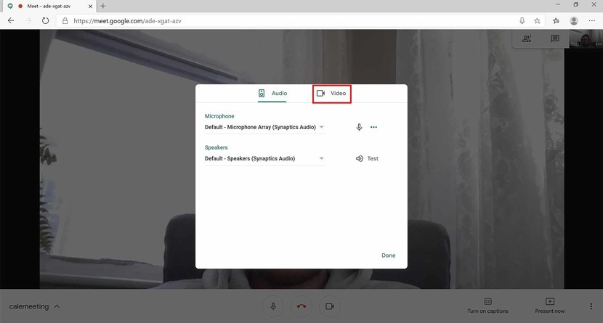Source: Windows Central
- Click the dropdown menu below Camera to choose a recording device.
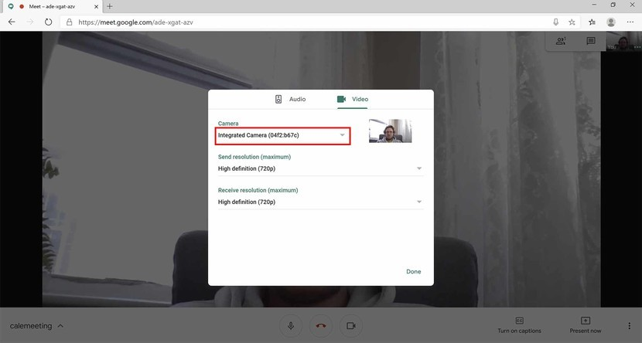Source: Windows Central
You can also change the send resolution and receive resolution from this menu. This is particularly important if you're on limited data or have a slow connection.

How to share your screen in Hangouts Meet
Have something important on your PC that you want to share with the rest of the team? You can broadcast what you're seeing to everyone in the Meet.
- Click Present now.
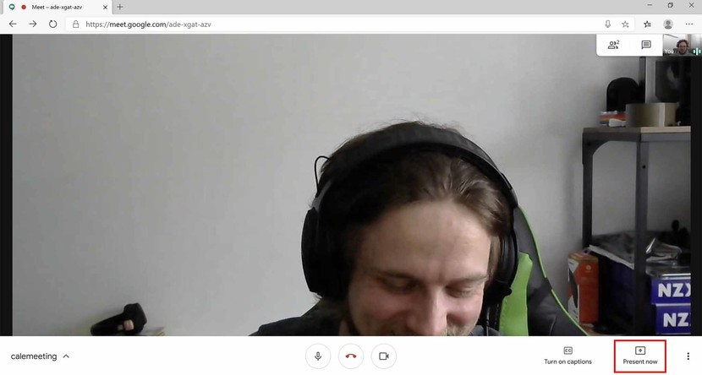Source: Windows Central
- Click Your entire screen or A window depending on what you want to share.
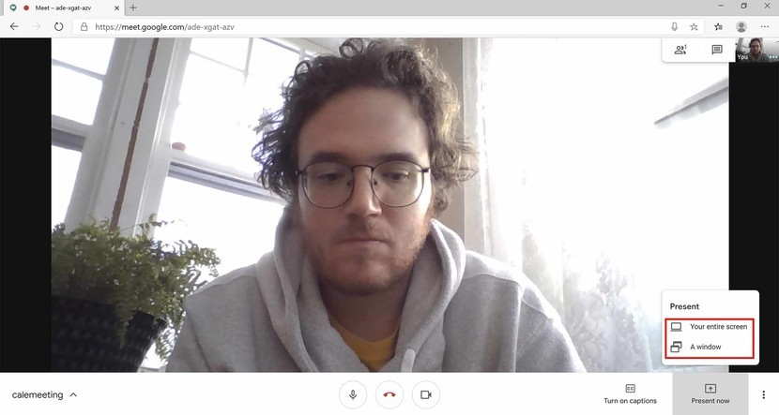Source: Windows Central
- Click a window or a screen (in the case of multiple screens) you'd like to share.
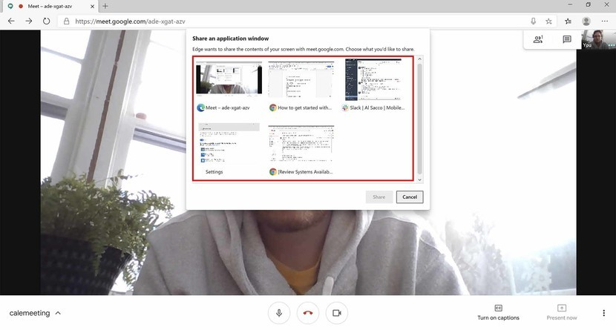Source: Windows Central
- Click Share.
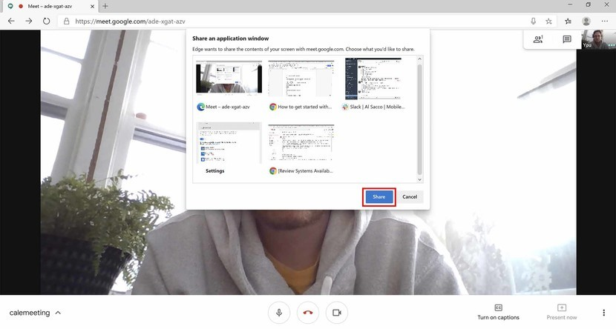Source: Windows Central
- Click Stop presenting when you'd like to stop sharing your screen on a window.
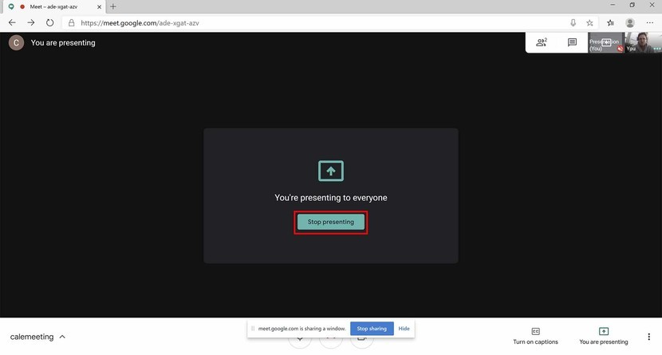Source: Windows Central

How to send a text message in Hangouts Meet
Have something to say but don't want to butt in on the audio and video? Don't have a microphone set up? You can send a text message that is visible to anyone within the Meet.
- Click the Text button in the top-right corner. It looks like a dialogue bubble.
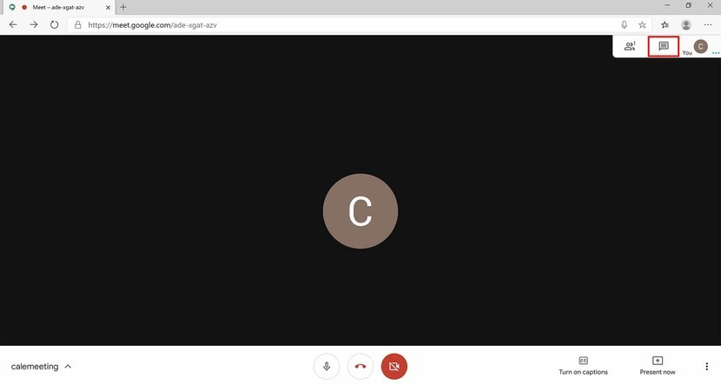Source: Windows Central
- Type a message and hit Enter on your keyboard.
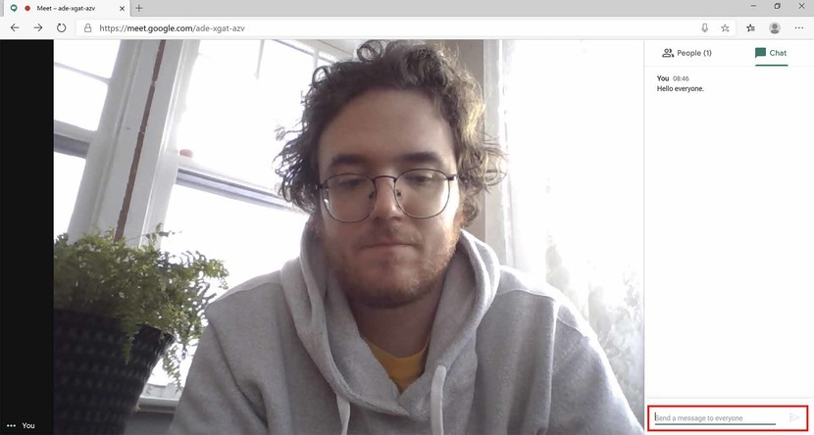Source: Windows Central
Within this side panel will be collected any messages sent by people within the Meet session.

How to remove someone from Hangouts Meet
If someone joins your Meet session and you'd like to give them the boot, here's how it's done.
- Click the People button in the top-right corner.
Source: Windows Central
- Click the person you want to remove from the Meet.
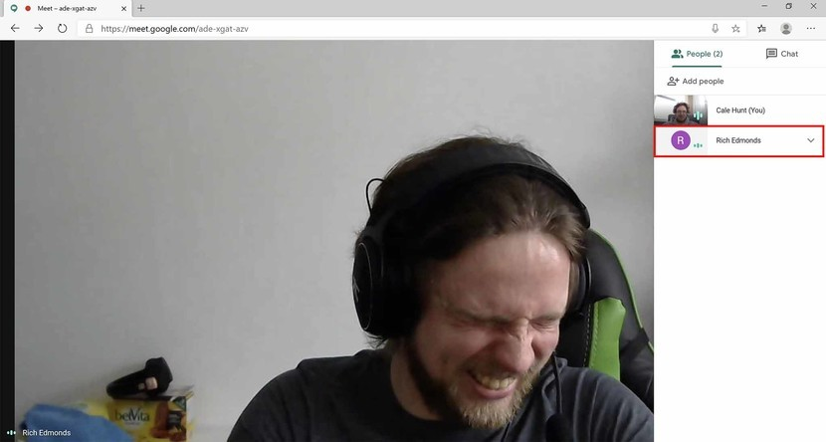Source: Windows Central
- Click the Remove button.
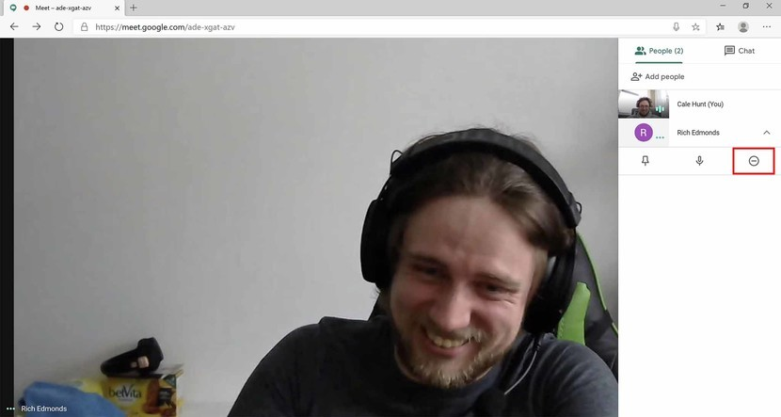Source: Windows Central
- Click Remove.
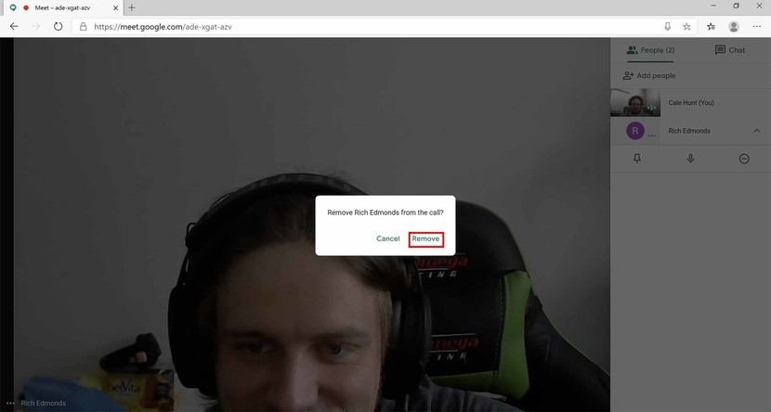Source: Windows Central

How to lock view on one person in Hangouts Meet
- Click the People button in the top-right corner.
Source: Windows Central
- Click the person on which you want to lock view.
Source: Windows Central
- Click the pin.
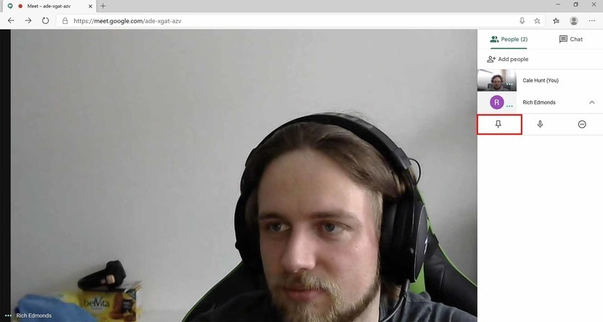Source: Windows Central
- Click the pin again to remove the view lock.
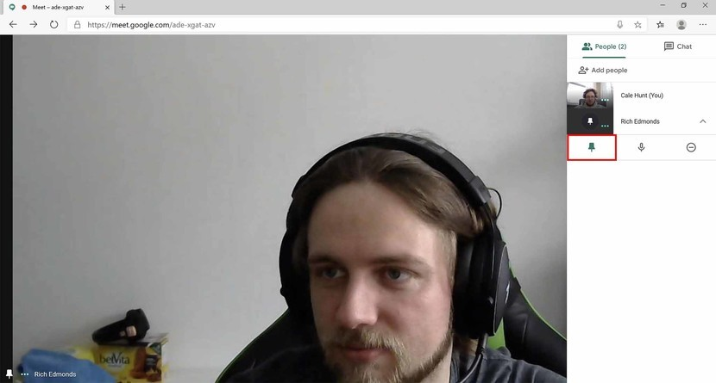Source: Windows Central
Alternatively, you can instead click on a person's bubble on the right side of the screen to lock them into view. Just click them again to remove the lock or click a different person's bubble.

How to change the layout of Hangouts Meet
The default view of Meet is a single person (whoever is talking unless you're locked onto someone) at the forefront with a sidebar at the side. However, you can change the layout to have more than one person on your screen at once.
- Click the Options button in the bottom-right corner. It looks like three dots stacked on top of each other.
Source: Windows Central
- Click Change layout
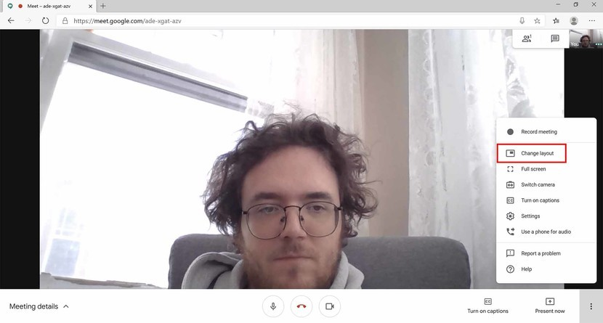Source: Windows Central
- Select a layout from the popup window. The tiled option should show multiple people at once instead of a single person.
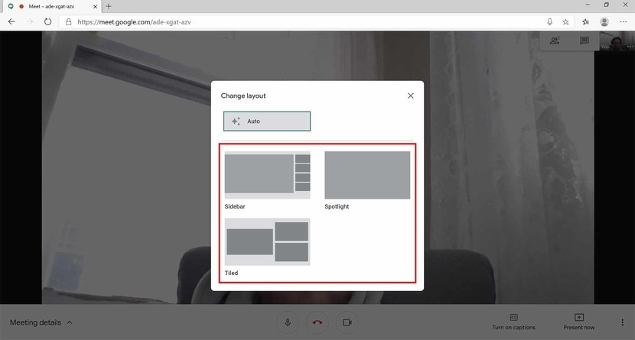Source: Windows Central

Our top equipment picks
If you're working from home and don't have a laptop with built-in mic or webcam — or you just want to upgrade — these are some great options for new hardware that won't break the bank. And, if you're not already a G Suite subscriber and want to take full advantage of Hangouts Meet, have a look at subscription options starting at $6 monthly.
Be sure to have a look at our roundup of best high-quality microphones for a more premium approach, and also have a look at our best webcam roundup for more options.

